**TABLE OF CONTENTS**

**ABSTRACT........................................................................................1**

**CHAPTER – 1: INTRODUCTION..................................................................2**

**CHAPTER – 2: LITERATURE SURVEY**

2**.1 Edge Detection....................................................................................3**

**2.2 Masking... ...........................................................................................4**

**2.3 Cropping………………………………………………..……………5**

**2.4 Haarcascade………………………………………..………………..5**

**2.5 Pytesseract……………………………………..………………….....6**

**2.6 OpenCV………………………………………..………………….....6**

**2.7 Sending E-mail………………………………………………………6**

**CHAPTER – 3: PROBLEM STATEMENT …………………………………7**

**CHAPTER – 4: PROPOSED SOLUTION …………………………………..8**

**CHAPTER – 5 : EXPERIMENTAL SETUP AND RESULT ANALYSIS**

**5.1 Experimental Setup............................................................................9**

**5.2 Solution Approach.............................................................................10**

**5.2 Result Analysis...................................................................................11**

**CHAPTER – 6 : CONCLUSION & FUTURE SCOPE……………………..12**

**BIBLIOGRAPHY .............................................................................................13**

**ABSTRACT**

We are using technology in various aspects of daily life, such as vehicle parking, toll services, and traffic management scenarios, a Vehicle Number Detection and Tracking System is essential. An exponential increase in number of vehicles necessitates the use of automated systems to maintain vehicle information. The information is highly required for both management of traffic as well as reduction of crime. Number plate recognition is an effective way for automatic vehicle identification. License plate recognition (LPR) plays a significant role throughout this busy world, owing to the rise in vehicles day by day. Stealing of vehicles, breaking traffic rules, coming into restricted space also are increasing linearly, thus to dam this act registration code recognition is intended.

Among the fundamental process steps such as detection of number plate, segmentation of characters and recognition of each characters, segmentation plays an important art, since the accuracy of recognition is based on how perfect the segmentation is done. To avoid problems like unwanted illumination, tilt that degrades the segmentation which in turn affects the recognition accuracy numerous algorithms are developed for this work. This report presents a strong technique for segmentation and recognition of the characters within the located plate. Images from still cameras are obtained and regenerated in to grayscale images. The segmentation of grey scale image generated by finding edges for smoothing image, different objects like tree shadow and all are removed for a clear observation. Finally, single character within the registration code is detected. The aim is to indicate that the planned technique achieved high accuracy by optimizing numerous parameters that has higher recognition rate than the standard ways. Some of the existing algorithms based on the principle of learning takes a lot of time and expertise before delivering satisfactory results but even then lacks in accuracy. In the proposed algorithm an efficient method for recognition for vehicle number plates has been devised. Our technology is getting advanced day by day which helps in every field. Our work focuses on getting the vehicle number plate and getting its detailed picture as well as in text which can be forwarded to different sources in the time of needs. In this report we are trying to approach the number plate of a vehicle by using different algorithms and get its clear picture. We are then approaching to get the number plate in the form of text.

For which we had used different functions and technology which we will get a better idea about in the report further.

# INTRODUCTION

Number plates are placed at the front and back of the vehicle and help anyone to identify a vehicle.

With the help of the technologies, we use number plate detection system that empowers various applications such as fast-track payment at toll plazas, tracing stolen vehicles, automated parking systems, and road safety systems. Hence, number plate recognition is essential. Vehicle number plate detection is a technology that reads vehicle registration plates to create location data. This information is captured by scanners or cameras then cross-referenced for a range of traffic and law enforcement purposes. Number plate recognition is a technology that uses optical character recognition on images to read vehicle registration plates to create vehicle location data. It can use existing closed-circuit television, road-rule enforcement cameras, or cameras specifically designed for the task. This system is used by police forces around the world for law enforcement purposes, including to check if a vehicle is registered or licensed. It is also used for electronic toll collection on pay-per-use roads and as a method of cataloguing the movements of traffic, for example by highways agencies. Automatic number-plate recognition can be used to store the images captured by the cameras as well as the text from the license plate, with some configurable to store a photograph of the driver. Systems commonly use infrared lighting to allow the camera to take the picture at any time of day or night. Vehicle tracking technology must take into account plate variations from place to place.

Uses of Number plate detection are mainly Traffic control and Electronic toll collection.

**LITERATURE SURVEY**

# 2.1 Edge Detection

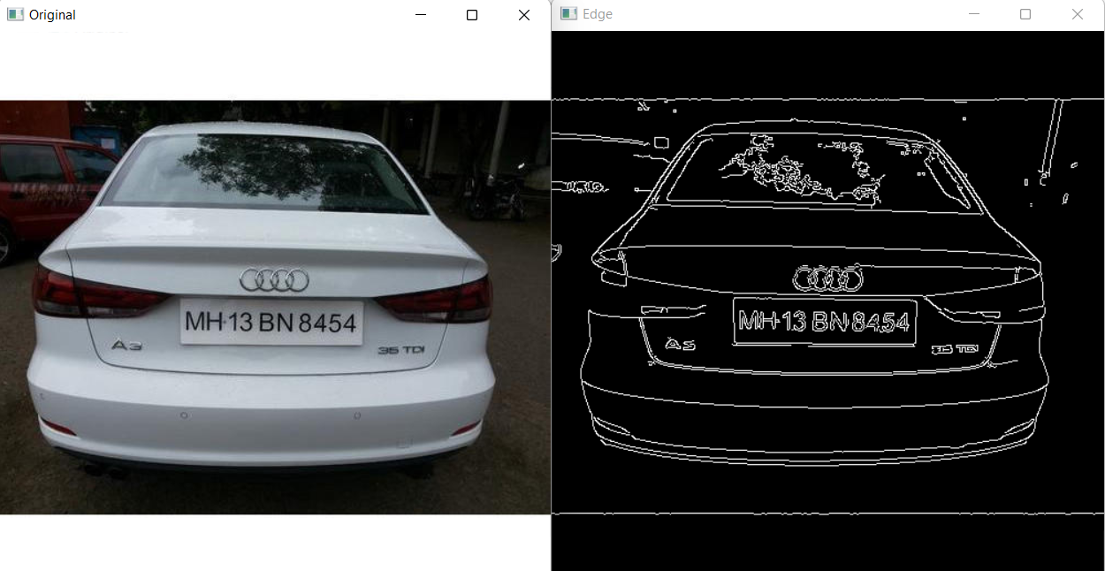Edge Detection, is an Image Processing discipline that incorporates mathematics methods to find edges in a Digital Image. Edges are characterized by sudden changes in pixel intensity. To detect edges, we need to go looking for such changes in the neighboring pixels. We have used this technique to detect the points of the contours from the edges and printing the points of the polygon closest to the shape of rectangle. This will help us to get just the number plate from the entire image. [1]

# 2.2 Masking

Masking is used in Image Processing to output the Region of Interest, or simply the part of the image that we are interested in. The numpy and opencv module has been used to perform this particular operation. We have retained the polygon obtained from edge processing,i.e., the number plate and turned the remaining portion of the image black. [2]

# 

# 2.3 Cropping

Masking leaves us with just the number plate part of the image while the rest of the image is black in colour. The number plate is then cropped out using the min and max functions of the numpy module. [3]

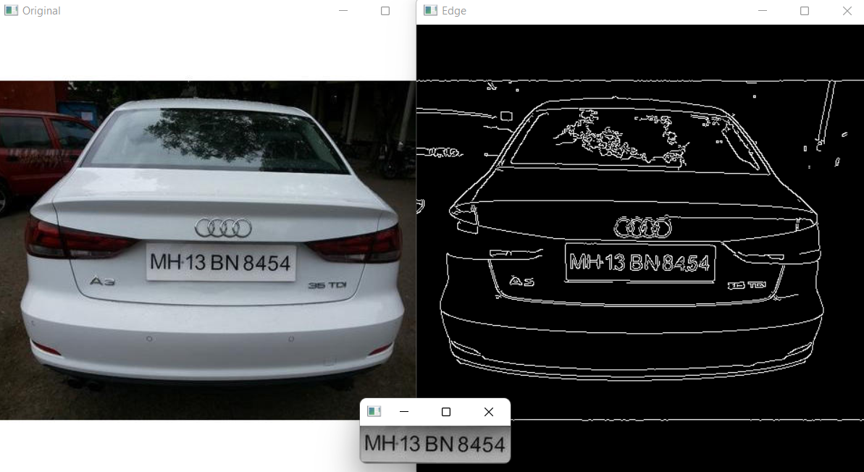

# 2.4 Haarcascade

Haarcascade works as a classifier. It classifies positive data points that are part of our detected object and negative data points that don’t contain our object. Using haarcascade we have identified the number plate and have cropped it out of the image. Here we have an XML fine that has the contours value stored in it. This makes it possible to identify and crop the image in this procedure. [4]

# 2.5 Pytesseract

Python-tesseract is an optical character recognition (OCR) tool for python. That is, it will recognize and “read” the text embedded in images.Tesseract, when integrated with powerful libraries like OpenCV, can be used to combine the tasks of localizing text (Text detection) in an image along with understanding what the text is (Text recognition). [5]

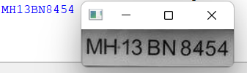

# 2.6 OpenCV

OpenCV is an image and video processing library with bindings in C++, C, Python, and Java. OpenCV is used for all sorts of image and video analysis, like facial recognition and detection, license plate reading, photo editing, advanced robotic vision, optical character recognition, and a whole lot more. It is imported as cv2.[6]

**2.7 Sending E-mail:**

Here, we are going to send a mail containing the detected number from the number plate using [Python](https://www.geeksforgeeks.org/python-programming-language/) code. Python offers a library to send emails- “[SMTP](https://www.geeksforgeeks.org/simple-mail-transfer-protocol-smtp/) lib”. “smtplib” creates a Simple Mail Transfer Protocol client session object which is used to send emails to any valid email id on the internet. The Port number used here is ‘587’.  [7]

**PROBLEM STATEMENT**

1. It is required to keep a track of vehicles that overspeed on detect overspeeding vehicles, vehicles that drive rashly, or any accidental occurrence.
2. Criminal cases require tracking of vehicles to find out details about it’s possession and to track it’s live location.
3. Parking lots face problems like stress of managing their own tickets and tracking time spent, risking penalties for inaccurate ticket payments or losing their tickets.
4. Toll booths operating manually require more time to collect payments and print receipts which disrupts the smooth functioning of toll booths on busy roads.

**PROPOSED SOLUTION**

The project we made will certainly help the Police to keep a track of vehicles over speeding or violating the rules of traffic as our project detects the vehicle’s number plate as soon as it is captured or any image of vehicle is given as input. Not only it detects the vehicle’s number plate but automatically the vehicles’ number plate is registered in a certain email or phone number. It is useful in criminal cases too like in case of any kidnap we can trace the vehicle’s number plate and soon find the car’s owner. In parking lots too its useful as tracking the number plate, the parking lots can give the vehicle a certain place to park which then it gets saved to their databases for any future use. The toll booths need not to print receipts manually but they can receive the payment and the receipt with the car’s number plate written automatically on that receipt.

**EXPERIMENTAL SETUP AND RESULT ANALYSIS**

**Experimental Setup:**

1) **Number Plate Detection:**

●Both frontal and back plates are considered in the solution.

●Due to lack of unavailability of annotated Indian car images with number plates, a mix Cars is used for training purpose.

●Cases, where cars are in some angle, are considered.

Image of any dimension has been considered.

2) **Text Extraction from Detected Number Plate:**

● The output of Number Plate Detection solution.

● Only cropped number plate fed to pytesseractand not the entire image

● Text with size 12pts is the best extracted.

3) **Software and Libraries used:**

We have used Python programming language as the base language to develop the application. Here we are using libraries like OpenCV, numpy, imutils, smtplib and pytesseract.

**Solution Approach:**

The problem has been divided into 2 parts:

● Number Plate Detection

● pytesseract over-extracted Number Plates extracted

**Our solution has been approached in the following ways:**

● Dataset preparation for training (Training/Validation) of Object Detection model

● Using Gray scale concept to remove extra colours to make the process fast.

● Using Noise Reduction concept to remove noise from the picture for better clarity.

● Now using edge Detection to detect all the outlines from the picture.

● After edge detection we are sorting all the shapes present in the picture and saving them in an array, after that we are searching an rectangle shape ore a polygon close to rectangle.

● Then we are cropping the picture of the rectangular number plate.

● After that we are reading the number from the cropped out number plate and displaying it as output.

● We are further sending the detected number plate to a provided email address to be kept for further reference.

**Algorithms Used:**

A) Number Plate Detection: Implementation of Gray Scaling, noise redudction edge detection and using Haarcascade xml file "haarcascade_russian_plate_number.xml" in the following project

B) Text Extraction from Number Plate: For text extraction from images we are using Pytesseract.

**Result Analysis:**

Results showed that the accuracy and processing time of the proposed algorithm using template matching was 97.5% and 1.13 seconds, respectively. On the other hand, the traditional algorithm using template matching only obtained 83.7% recognition rate with 0.98 second processing time.

Our algorithms has required 3.14 seconds and has an accuracy of 85.6%. It shows that our proposed Vehicle Number Plate Detection algorithm works with proper accuracy but at a slightly higher time consumption.

**CONCLUSION & FUTURE SCOPE**

**CONCLUSION**

The project helps to recognize Vehicle Registration numbers through digital image processing. From this system we have effortlessly obtained the various results such as

• To locate the vehicle’s number plate if it has violated the traffic rule.

• The data can be easily stored and transferred which makes the system more efficient.

This project performs some efficient tasks. In this project we are giving a vehicle’s picture as input where its gray scaled and the edges are detected from which the shape closest to rectangle are found and the number plate is detected and the letters in the number plate are extracted and is sent to a certain email address.

**FUTURE SCOPE**

The system that we build is a classic approach of finding vehicles which has violated the traffic rules and day by day its uses is increasing. The benefits of vehicle tracking are wide-ranging and include traffic management, retail park security, toll booth records, and journey time analysis. As such, it is no wonder that vehicle tracking has become so popular in recent years, the global automatic number plate recognition market is rapidly growing, and we see disruptive number plate detection projects across industries such as transportation, logistics, security, and the public sector. This is also cost effective than most other systems.

Vehicle Number Plate Tracking has many uses including:

* Recovering stolen cars.
* Identifying drivers with an open warrant for arrest.
* Determining what cars do not belong in a parking garage. Expediting parking by eliminating need for human confirmation of parking passes.